JUNIT 5 NOTES
………………………………………………….AGENDA……………………………………………………………………
WHAT IS TEST AND WHAT JUNIT
WHAT IS MAVEN
ASSERSION AND ANOTATION
TEST LIFECYCLE
J UNIT 5 ARCH.

UNIT TEST IS SMALL PIECE of CODE AND THAT’S CALL
ANALOGY ------- YOU BECK A CAKE BEFORE SELL IT U TEST TEAST
IS UNIT IS TETS TEST CHECK DONE BY COMP
WITHOUT TEST WE CAN WRITE

2. What is Unit Testing?
Unit testing means testing a small, individual piece of code, such as a method or function.
- A unit is a small piece of code.
- A test checks whether that code works correctly.
- Unit tests are usually automated.
- They help find bugs early.
- JUnit is a tool used to write and run unit tests in Java.

3. What is Maven?
Maven is a build automation and dependency management tool for Java projects.
It helps developers:
- Download libraries such as JUnit.
- Compile Java code.
- Run tests.
- Package applications.
- Manage project dependencies using pom.xml.

What is JUnit 5?
JUnit 5 is a testing framework in Java used to write and run automated unit tests.
It helps developers check whether their Java code works correctly without manually testing everything.
3 Steps of Unit Testing
- Arrange – Prepare the data and objects required for the test.
- Act – Execute the method you want to test.
- Assert – Check whether the actual result matches the expected result.

Maven is a build automation and project management tool used in Java projects.
Maven mainly does these 3 jobs:
- Dependency Management: Downloads and manages required libraries, such as JUnit 5, automatically.
- Build Management: Compiles Java code and packages it into a JAR or WAR file.
- Testing and Reporting: Runs tests and generates test reports.

Pom.xml is like shopping list project object model;
If we are cooking kitchen example
2. Scenario: You join a new project
Kitchen example: A new chef receives the recipe and shopping list instead of asking everyone which ingredients to buy.

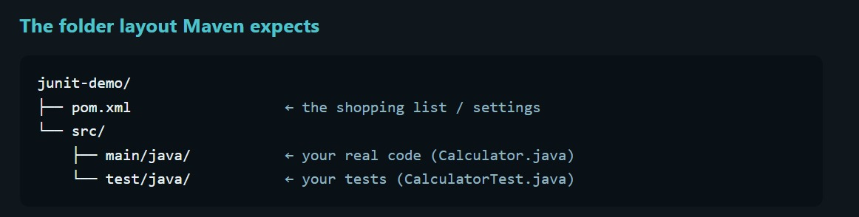

Common maven syntax

Mvn -v …………check
Mvn compile………..complie src and main
Mvn test……………………complie everything and test runs presnt in folder
Mvn clean test………………….dlt test or clean.

Steps for j unit
Understand the problem and write down psedo code
Write code
Write test
Run test

j unit PLATFORM
ENGINE ROOM START TEST TALKS TO IDS AND MEVEN , DEFINE HOW TEST ENGINE PUGINS
IT IS USE BY VS CODE INTELLIJ , MAVEN SUREFIREE

………………………………………………………JUNIT JUPITER …………………………

The new programming model: @Test, @BeforeEach, assertions. Also contains the engine that runs Jupiter tests.
IT IS UESD BY DEVLOPER WHILE WRITING TEST
@Test
@BeforeEach

JUNIT VEINTAGE API
COMPBILITY ENGINE THAT RUN JUNIT 3 AND 4 TESTS ON NEW PLATFORM .
IT IS USED BY OLD PROJECTS THAT HAVENT YET MIGRETED
ANOLOGY ……
CEINEMA HALL
PALTFORM IS BULDING , PROJECTOR STYSTEM AND TICKET COUNTER ITS MEANS JUNIT PLATFROM IT CAN SHOW ANY MOVIE.
JUPITER IS TODAY MORDEN MOVIE THE ONLY ONE YOU CAN WRITE
VINTAGE IS AN OLD MOVIE THAT RUN SAME PROJECTOR
THE BUILDING DOESN’T CARE THR MOVIE PLAYS AS ALONG AS A MAGIC ENGINE.

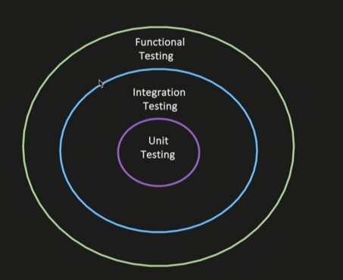

Unit testing
Testing is indivually test

Integration testing :

Componets together test …to test system that check wired together.
Testing multiple module
Goal is not to test end to end user behaviour.
Use case 1 :
Service > repo > DB
Wired multiple module of one module.
You invoke the method in service layer .
Verify dependenies.
Flow should reach DB layer.
Test can assert that data was persisted properly.
Service A > published to kafka : validate msg to sucussfully published the kafka topic.

Functional testing :
The end to end testing of feature functionlity verify work as expected .

